Claybanks Township
Pine Grove and Flower Creek Cemeteries
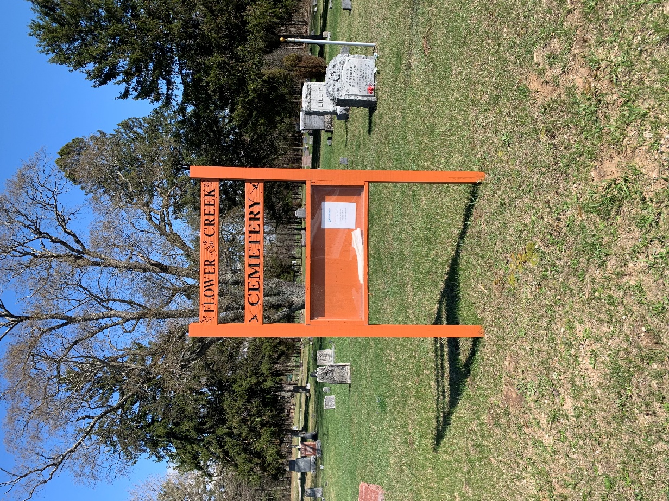

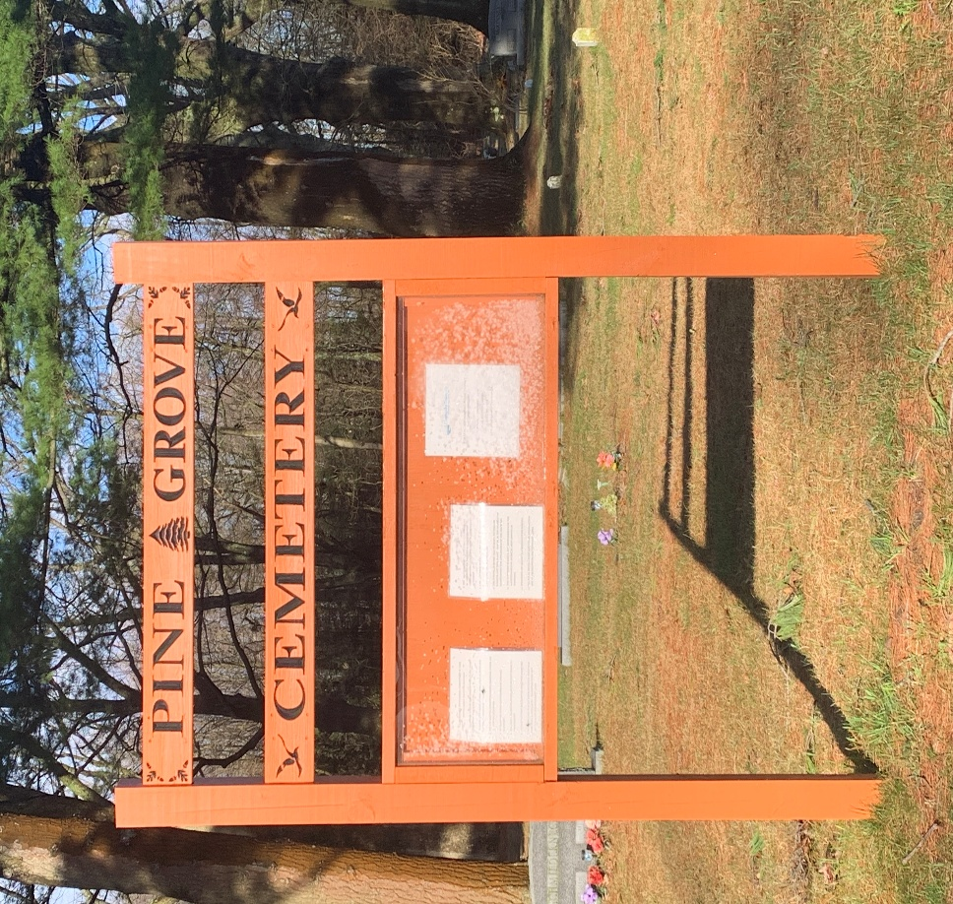

Lots contain 5 or 6 sites
$300 per site each for residentials only.
A site may contain 1 full burial and 1 cremation.
A site may contain 2 cremations.
All headstones require a cement base. Cost for the base materials and labor is $225.
Digging for a cremation cost is $100.
Winter cremation burials will cost $200. November to March.
Full burials will be handled by the funeral homes.
No planting of trees or bushes will be permitted.

